**Title - Fast future (Educational learning platform)**

**Concept of project:**

The fast future is an education learning platform designed to cater to the young generation with interactive learning and building interest to grow towards their innovative future.It will provide free learning plans and mass of information related to the technology and coding.Through this website many children unknown to education or children facing issues learning can form healthy relationships with education which can further result in their bright future.Through quality education we can increase opportunities for better life and decrease chances of the next generation being poor and not being able to excel in life.

**Problem Statement**

Despite there being different websites to learn about new technology and coding-related subjects, there is a requirement for in-depth source information and to actually build interest in a person’s mind. By providing in-depth and practical use of related topics, one can understand what they are interested in and how much they would enjoy the path of education.

Online education can help new learners explore outside books and make them familiar with usage of technology in today's world.

**Objectives of project**

* In-depth information - Collecting information through different resources and providing it in an engaging way can make students want to learn more and advance their scope in related material.
* Easy to navigate and interact - Interactive websites make learning easier and more helpful. Adding a chat assistant would help students understand and learn faster and more joyously.
* Attractive UI - A clear UI helps with less confusion and contributes to using the website more often. Good UI will help students be more engaged with gaining more knowledge.

**Data sources used**

Various websites to collect thorough information as well as free online materials.

Software used:

Front-end Development - HTML, CSS, Tailwind, JavaScript

Prototyping - Figma

Version control - Github

APIs and Integrations

Deployment – Vercel

**Features**

* Search bar for easy access
* Login and personalised learning
* Interactive bot assistant
* Review and rating and building community
* Clear UI

**Methodology**

The methodology for developing an educational website would require gathering highly accurate data,easy learning structure,interactive assistance,gathering feedback and reviews,adapting and changing better resources. Using all these key points, the Fast Future educational website can be built for learners who lack knowledge related to fast-changing technology or who want in-depth information. Such websites can help underdeveloped areas that live in the shadow of poverty.

**Probable Outcome**

* Enhanced learning among new students
* Increased access for improved learning
* Cost effective education for students
* Skill development to be job-ready among learners
* Providing data for future research and development

**Wireframing & Prototype**

Software prototyping & wireframing is the activity of creating prototypes and wireframes of software applications, i.e., incomplete versions of the software program being developed.

To understand how the website would be seen by users, we first have to create a wireframe and prototype model of it.

Link to visit figma:

<https://www.figma.com/design/4JTGh5g29UNk2Nt3Vc6IVz/Ibm?node-id=0-1&t=lh71awA2plEXN5Ed-1>

Following is the prototype of fast future, educational website:

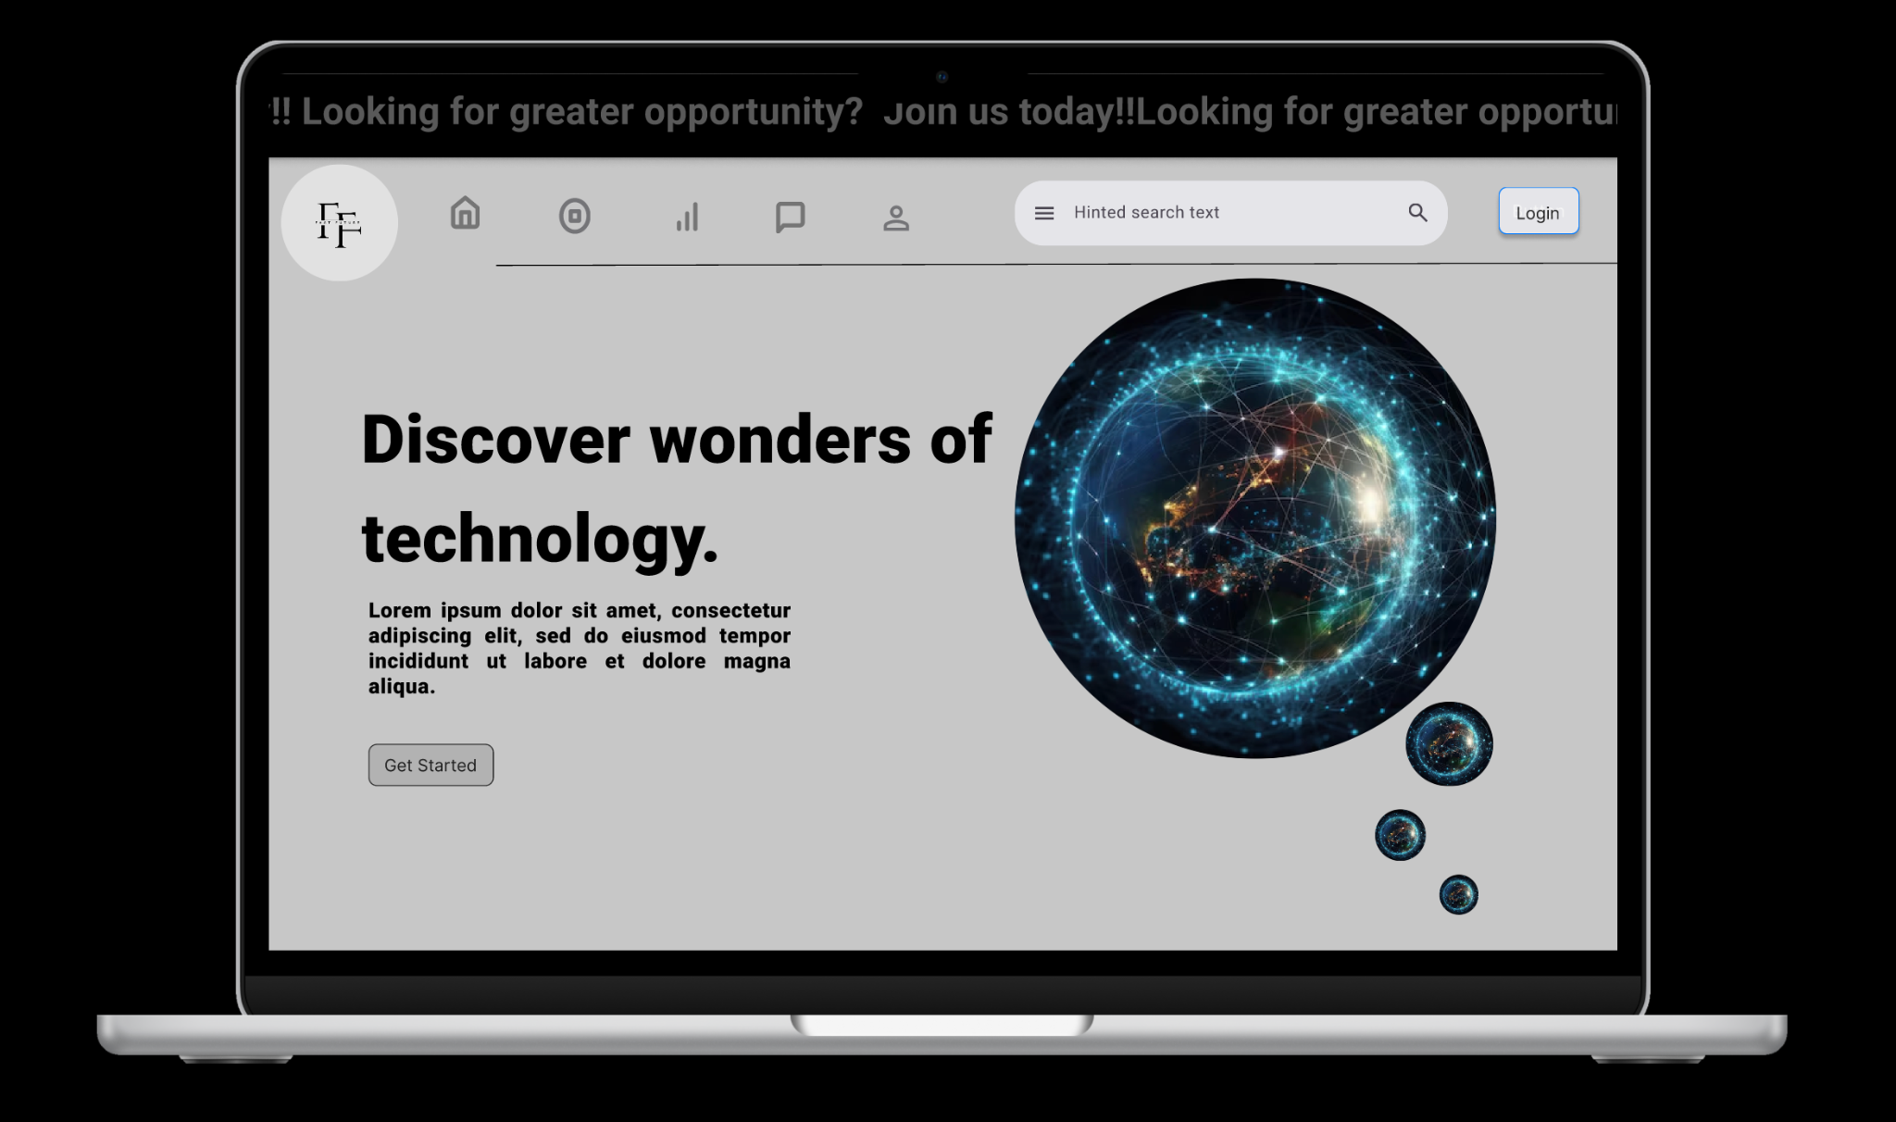

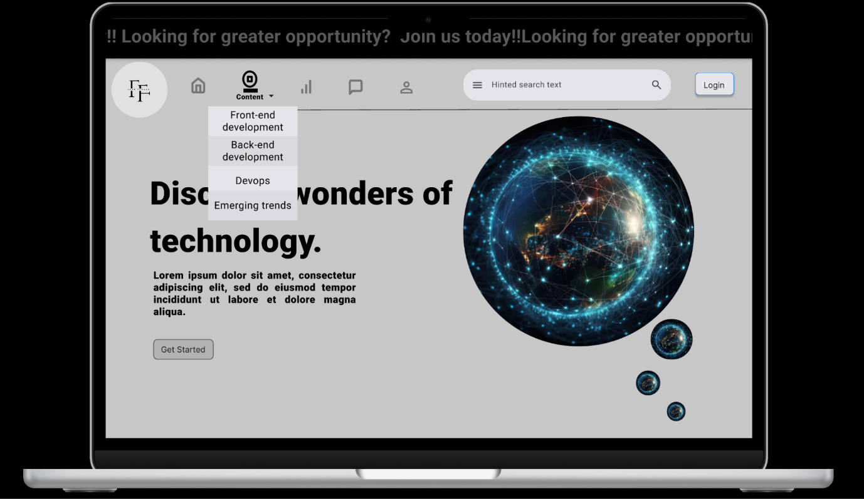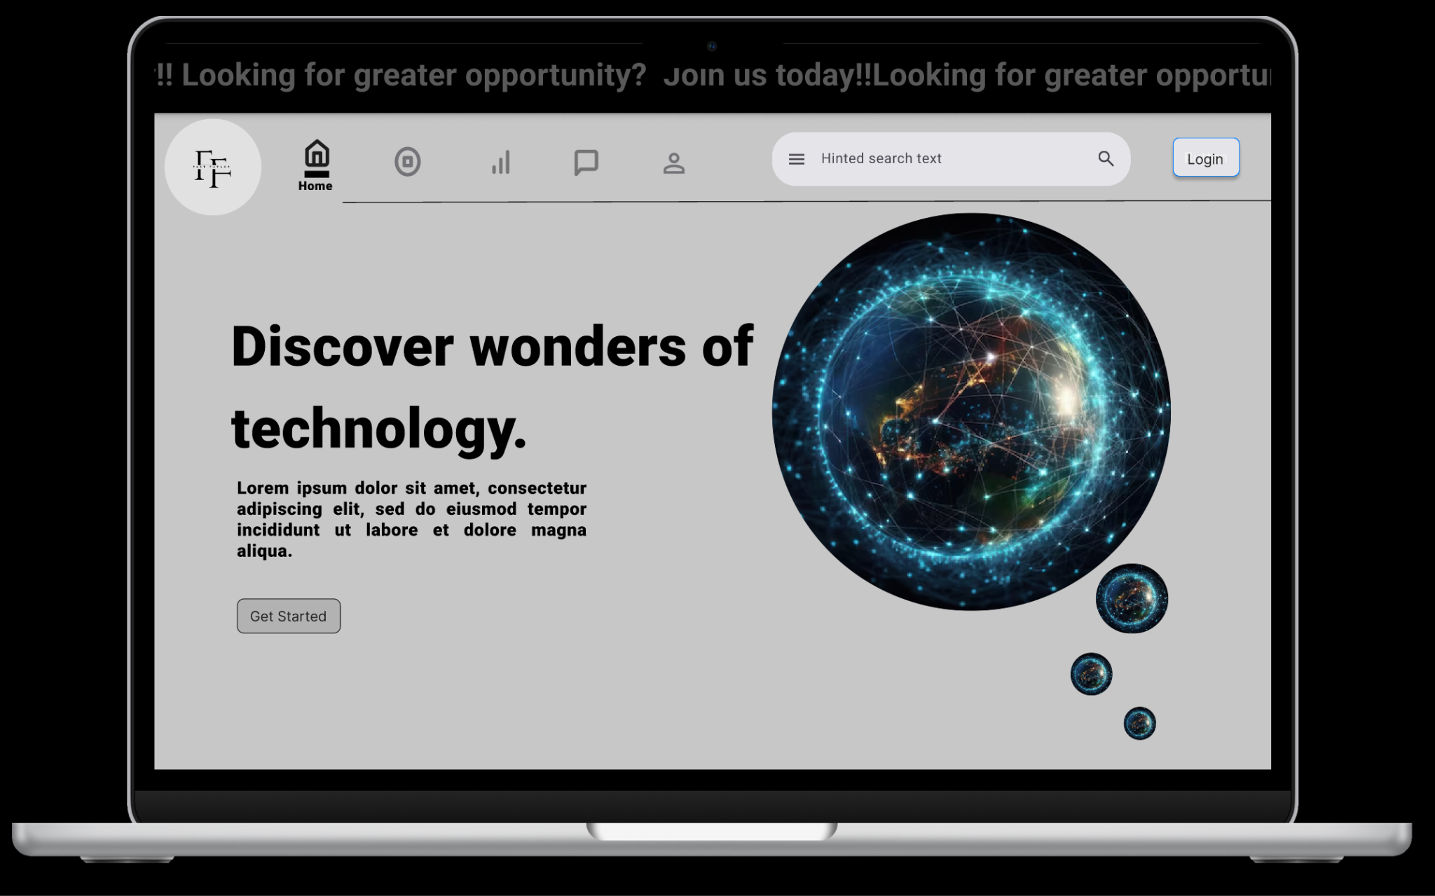

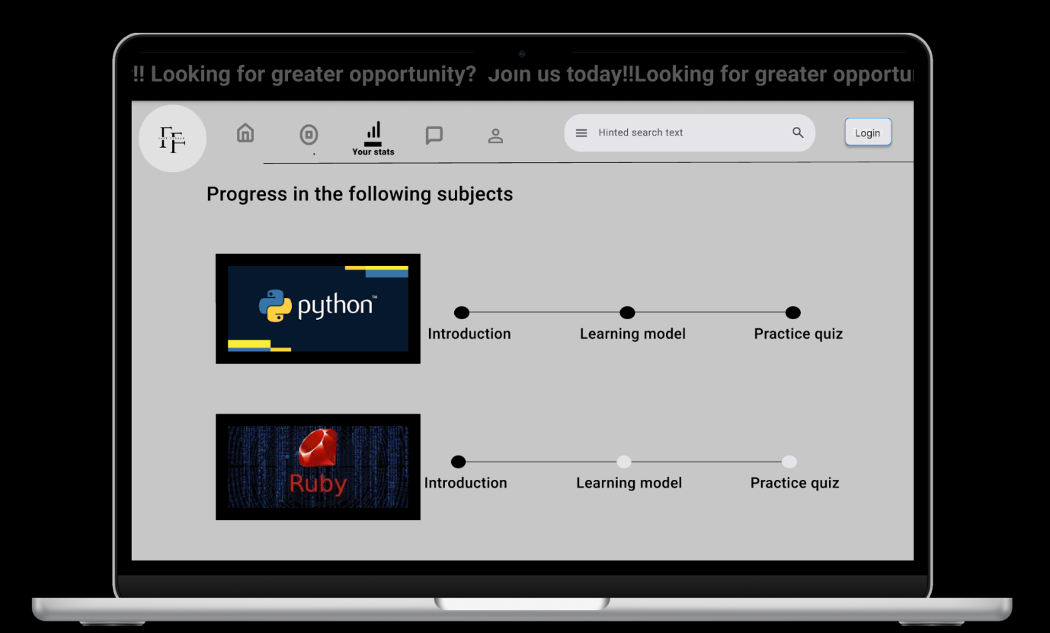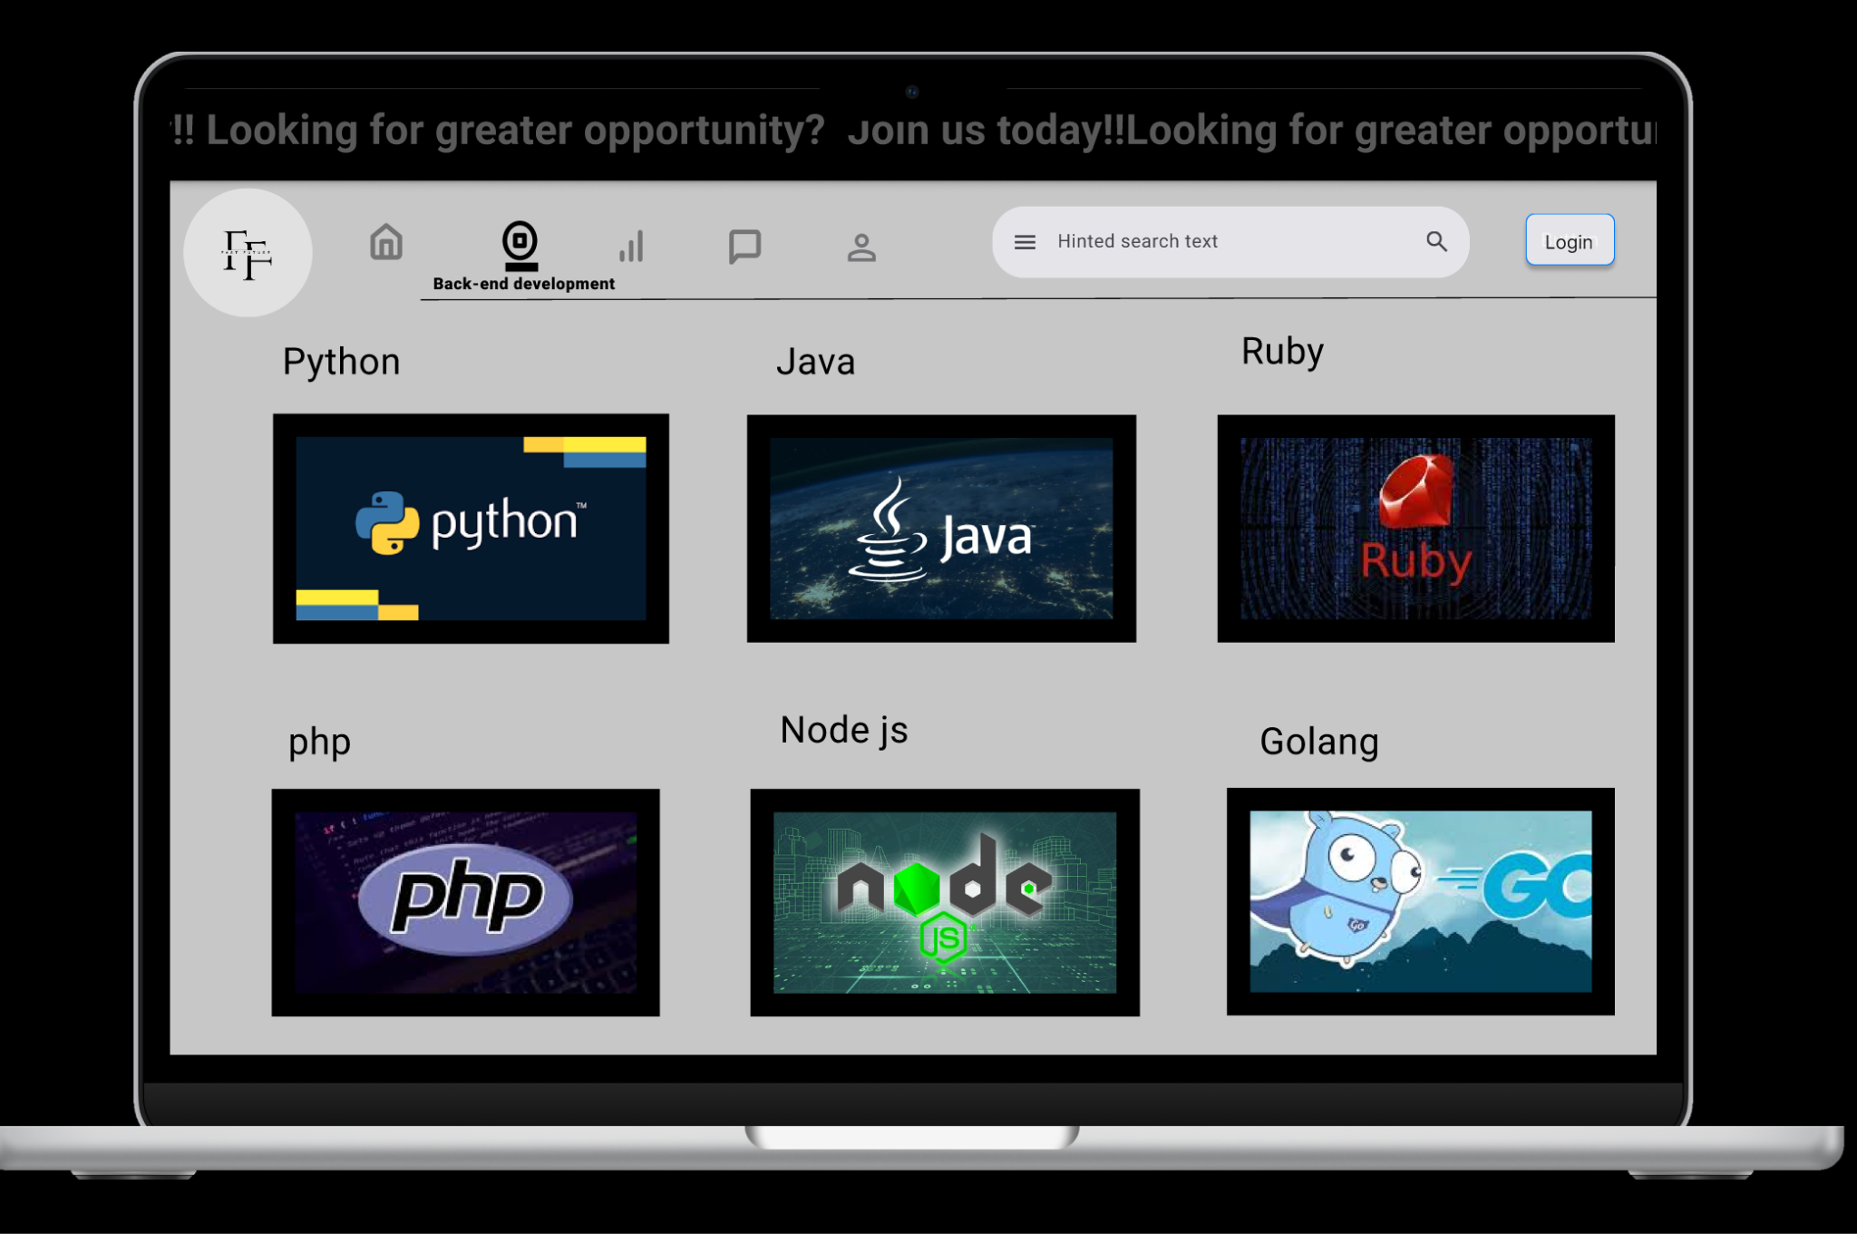

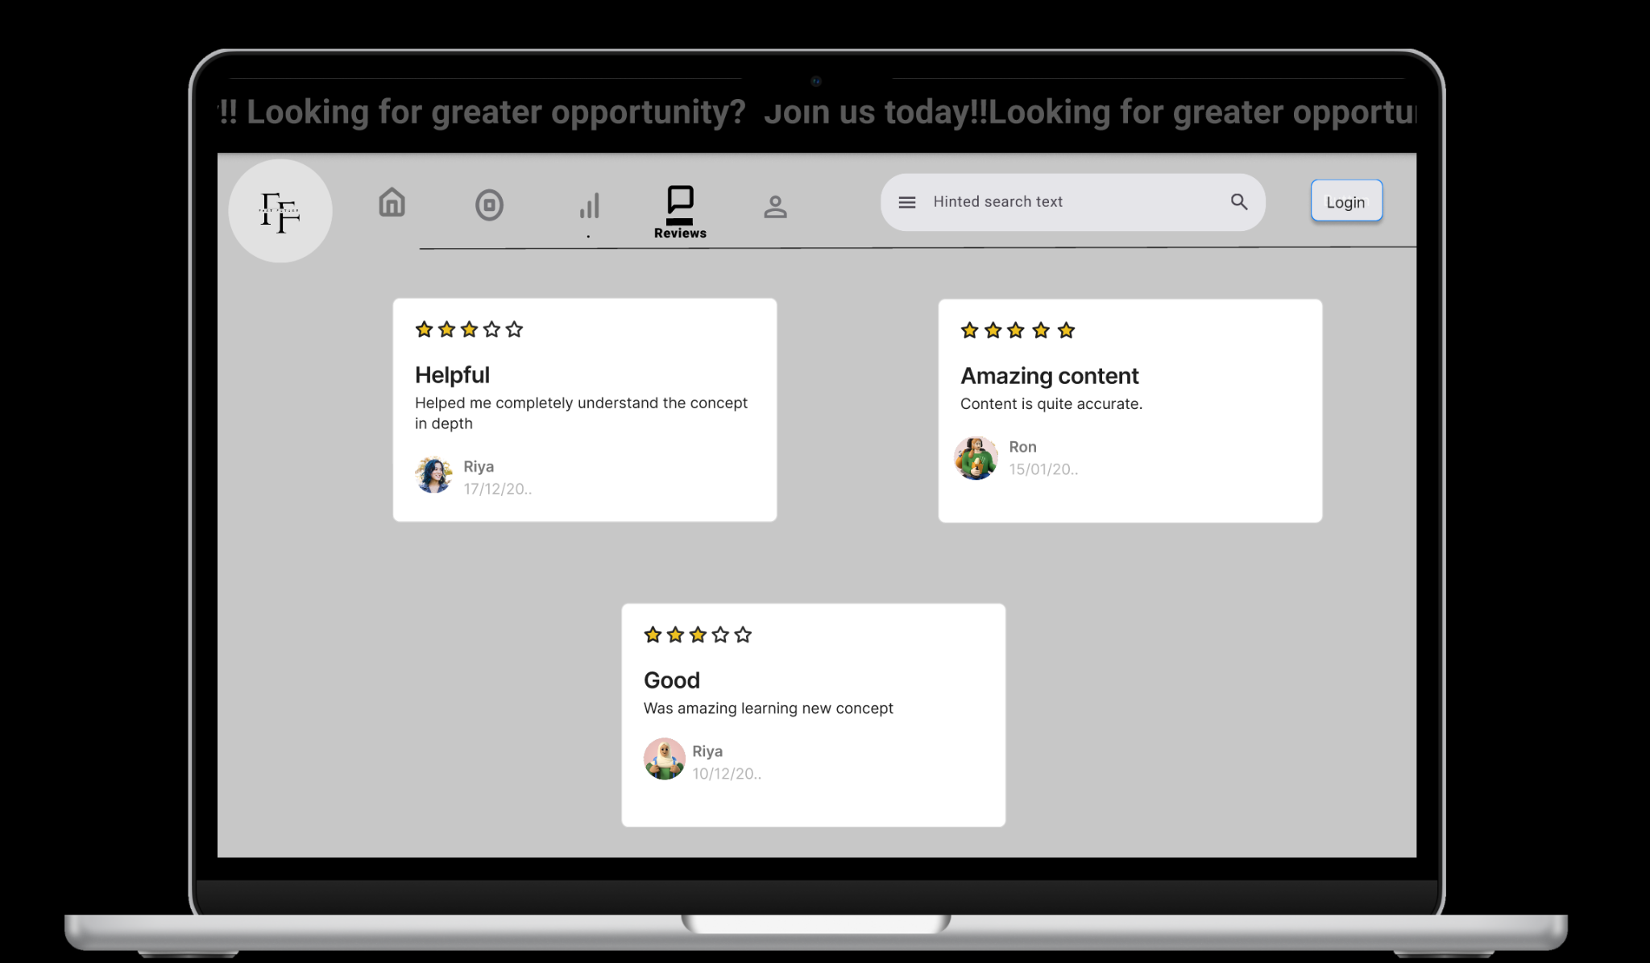

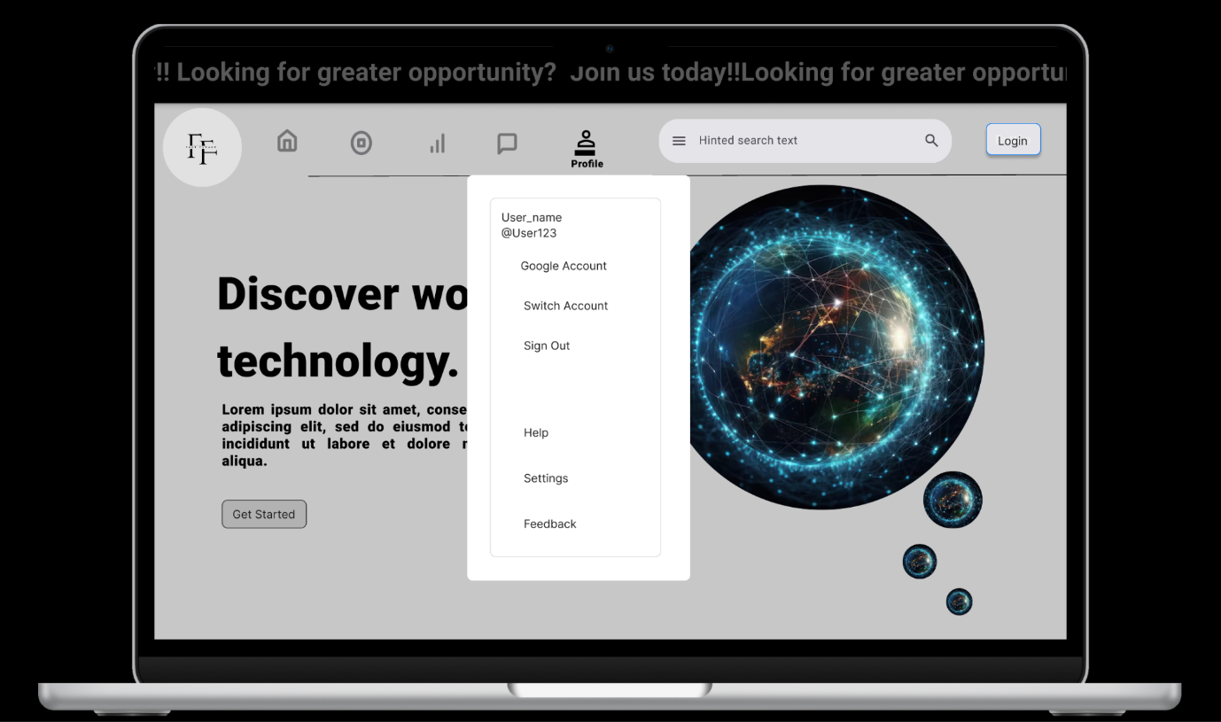

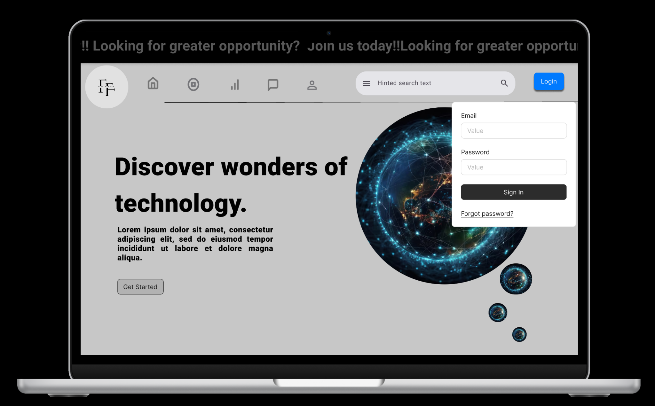

**Overview**

Fast future is a free educational website designed to promote passion for learning and equip them with skills required for future job opportunities. The website focuses on technology and coding with in-depth information and guides students for a brighter future. Creating a website that can push the idea of gaining knowledge and enjoying the path of it can help students from different parts of the country without any kind of discrimination can help in making developing countries into developed countries.